
LETS GO TO ST.PETERSBURG
Expectation method has also its limit. Consider the following game:
I will give you rupee 1 if head turns out on first toss and game stops, 2 rupees if it turns out on second toss and game stops and 8 rupees if it turns out on third toss and game stops and so on. What is the amount you pay to play game?
GAME

So, you can see that expectation for this game is infinite so one should eagerly bet all his fortune on this game but in fact when asked no one is ready to pay more than few rupees for this game.
This game is known as St. Petersburg problem.
Daniel Bernoulli from the famous swiss mathematician family applied himself to this problem and his labours brought forth the concept of utility in finance. He proposes that people does not evaluate wealth in terms of price but in terms of utility derived from that wealth. 500 rupee note/reward is more valuable to a poor person than a rich person. Therefore, they will take decision based on the utility/happiness derived from the wealth which in turn depends on the initial wealth.in short he introduced utility as some function of wealth and if expected utility from a prospect is positive then it is favourable in long term.
We can design therefore utility curve for everyone linked to his initial wealth. He further said one such function of wealth could be logarithmic such that U = LOG W. Take an example where one initial wealth is 100 and we try to see what happens when we add 10 on each step to its initial wealth. As you can see in excel that for each addition add less and less to the utility, we call it Diminishing marginal utility of wealth. ..\Desktop\Sample training folder\IOF(Part3).xlsx

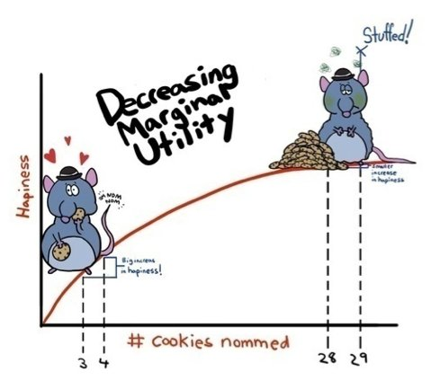

Let’s play one more Game. One must choose between these two options:
a) Equal chance of winning 10 and 90; b) 50 reward with certainty
As we can see in excel that one will chose 50 rupees with certainty and opt out from playing a risk. We call this behaviour as Risk averse means one tries to avoid or minimise risk. Quite correct and quite intuitive.
Daniel Bernoulli used elaborative maths to explain St. Petersburg problem using utility but for now we look it only intuitively. We can see in above chart that at some point adding more wealth does not add to utility much. It means for any individual with given wealth beyond a point he will not derive much pleasure by addition of wealth therefore Nobody will pay more than few bucks to play Petersburg game.
Mistake by Daniel Bernoulli
It is known that great empires were built when their founders took risk and did not settled for mediocre result. One such risk lover may opt for option a aiming for 90.Later in 20th century another Daniel born to solve and account for risk lovers.

